Hi,

I enclose your logon and password to the Russell Foster Youth Leagues website www.rfyl.org.uk There is a logon for each of your teams. This document that explains how to update the team page and registrations. Please take some time to read the document before making changes to the website.

TEAM CONTACT.

Once you have the username and password, logon to the website, then please make sure you click on Team Detail and fully complete with the name, address and email, and phone number of the team secretary, as this will always be our first point of contact. If you do not want the home address to be displayed on the public site, please remember to untick the box at the bottom of the page. This information in vital to the league as there are lots of reports depended on this info including exports for the FA.

GROUND DETAILS.

On the team contact page there is a drop-down menu option called ground. Please select ground then select 9v9, if U11 or U12, or 11v11 for U13 to U18. Grounds do not apply to small-sided as these are on central venues which we will add later. If your ground is not listed please send me the Full Name and Postcode of the ground and I will add it for you. If your ground has more that one pitch can you let mw know how many 9v9 and 11v11 pitches there are and how they are numbered.

REGISTRATIONS. (New Players to the League)

Before you set about your registration can I give you a few tips in preparation to do your online registrations. This season a registration form is not required to register a player. Please ensure that all boxes MUST be fully completed, including the Parent or Guardian email address. If any boxes are left blank this will invalidate the registration and it will be rejected. (Ignore the registration number box and Insurance Policy No.).

If a Parent or Guardian does not have an email address then a League Registration Form must be fully completed and upload to the website. In this case, the email address will be the club secretary.

Please ensure the email address in correct. Any invalid emails address the registration will be rejected.

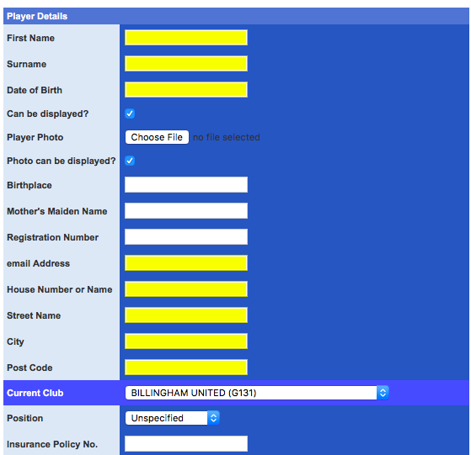

The reason the email is very important is because during the registration process the Parent will receive two emails. The first when you complete your part of the online form, and a second when the league have certified that the registration is correct. The email will advise the parents what is happening and the safeguarding issues.

Photo ID’s

All players require a current photo uploading to the website as part of the ID system. This photo must be of Head and Shoulder only.

PLEASE NOTE: Uploaded files (photo and documents) MUST be IMAGE files (.jpg, .png, .gif
etc.) and NOT .pdf documents.
Please DO NOT attempt to upload full-size, high-resolution images as the total upload must
not exceed 30MB
If you receive an error message, it is likely that your files are too big or of the wrong
File type. Also, if the player photo turns to the side, this is again because it is too big. Crop it again and upload again.

Once the photo is scanned to your computer, take a photo on your photo camera, then upload them to the website.

Proof of ID

Proof of ID only required to be uploaded to the website if the player is completely new to the Russell Foster Youth Leagues website. For this season, all small-sided teams, U11 and Girls must do this for the first season. Once again take a photo of the Birth Certificate, Passport or last season ID card and upload. This is now a compulsory field hence it is now in yellow.

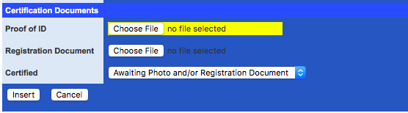

I would recommend that you first release any players that are not re-signing for your team this season so that their new team can pick up the registration details.

Once you have a photo and proof of ID’s upload and all details completed, then set the bottom drop menu option to awaiting certification.

From. To

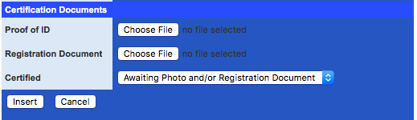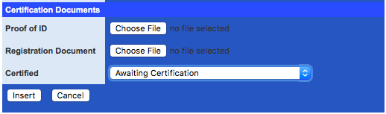

This will turn the players record YELLOW.

Once the players have been Certified by the Russell Foster Office, the players record will turn GREEN they will appear in the MyTeam tab and can be printed off for ID inspections and can be accessed on the mobile version of the website.

REGISTRATIONS. (Already on the Database)

If you wish to register a player for you club who is already playing in the league and has been released by his previous club. Go to players in Club Admin and under your team name there is a search box. Inset the players full name and date of birth if all these details are not entered they will not appear.

The player will appear in alphabetical order on your team list then press select he will then appear to the right-hand side. Scroll to the bottom select edit and amend his details ensuring all yellow boxes are full complete including the parents email address. ( no forms required unless the parents do not have an email address the a registration form MUST be completed.

If you require training on the website I enclose a list of dates.

All training will be held in the Russell Foster HQ in Newbottle, Houghton Le Spring and will commence at 6pm.

We have a maximum limit of 30 people per evening so book your place ASAP to avoid being disappointed.

To book a place please email or ring Allison Jones on 0191 5842120 between 9.00am to 5.00pm or email Allison.jones@rfyl.org.uk

The dates of the training are as follows: -

Clubs Wednesday 12th July 2017
Wednesday 19th July 2017
Wednesday 26th July 2017

If you require any more info on the website please email me and I will get back to you

Peter Maguire
League Website Manager.

